**Registering to use the RBKC LGPS**

**member self-service portal for the first time**

Email: [pensions@rbkc.gov.uk](mailto:pensions@rbkc.gov.uk)

Phone: 020 7361 2323 (9am – 5pm working days)

Website: <https://www.rbkcpensionfund.org>

Dear scheme member, thank you for enquiring to register with the RBKC LGPS member self-service portal (MSS) for the first time. The process of registering to use MSS for the first time is the same for all scheme members, regardless of whether you are an active member, deferred member or pensioner. To register to use MSS for the first time, follow the steps below:

**STEP 1** - Go to: [**https://mypension.rbkc.gov.uk**](https://mypension.rbkc.gov.uk)

**STEP 2** – On the top right of the screen, click on the **Login** icon

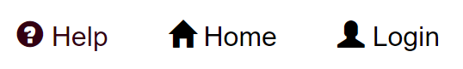

**STEP 3** – click once on the **Request one** link

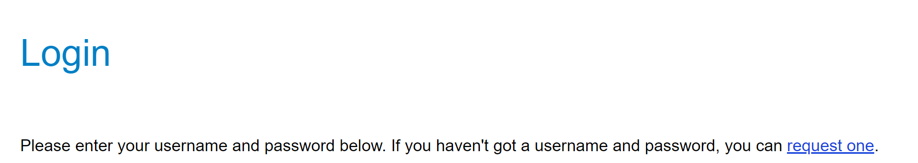

**STEP 4** – The **Sign Up** screen appears.

Enter your Surname, NI (National Insurance) Number, Date of Birth and Email address in each box, then click the **Sign Up** button once.

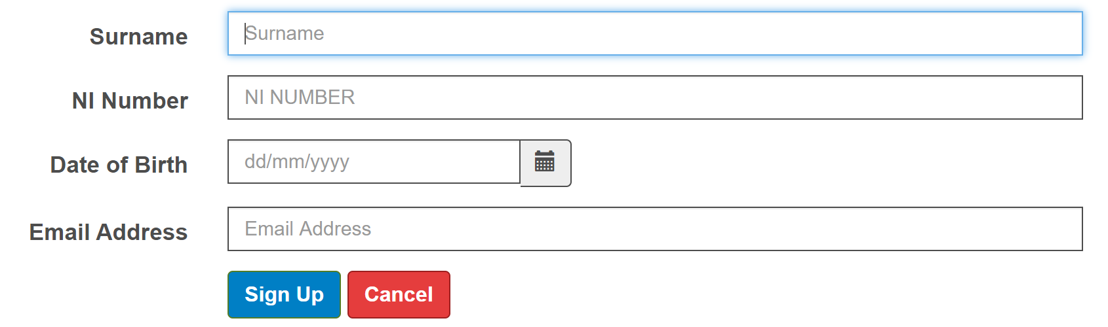

**If all your details match those we have on file…**

The following message will be displayed:



and you will receive an email from us, usually within 30 minutes. It will contain a unique link which, when clicked, allows you to complete the registration process and access your RBKC LGPS account, as in the example below. **Please check your junk folder to see if the email is there, and if so then move the email to your inbox BEFORE clicking on the link.**

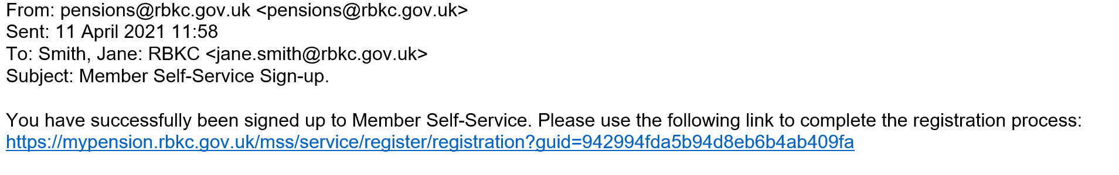

**If your email address is different to the one we have on file…**

If your Surname, NI Number and Date of Birth match our records, *but your email address is different,* the following message will appear. It states that you have successfully registered and that an activation key will be sent to you. RBKC Pensions will email your activation key to your nominated email account within one day, together with further instructions for completing the registration process:



**If one or more of the required fields do not match our records…**

If your surname, NI number or Date of Birth do not match our records, the following message will be displayed:

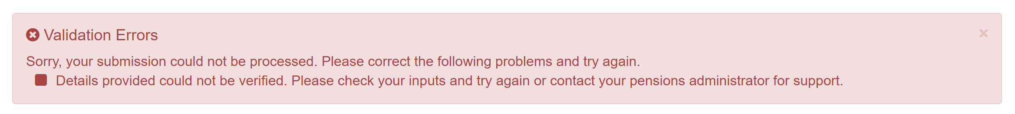

This means one or more of your personal details cannot be matched to a valid record on our pension system. In this situation please email us at: [**pensions@rbkc.gov.uk**](mailto:pensions@rbkc.gov.uk) and we will investigate and get back to you. We may ask you to provide additional proof of identity before sending an activation key to you.

RBKC Pensions, April 2022