**How to request an estimate of your pension if you are currently an active member of the RBKC LGPS using Hampshire’s IBC system**

**April 2022**

If you are currently an active member of the RBKC LGPS and you also are a user of the Hampshire IBC system, this document explains the process you need to follow to make a request for Hampshire to supply RBKC Pensions with your projected pensionable pay figures to your proposed last day of employment or flexible retirement date (whichever is appropriate).

Note: Flexible retirement requests are an employer discretion and are subject to approval by the Director of Human Resources. Please speak to RBKC Pensions if you are unclear about the process for seeking flexible retirement.

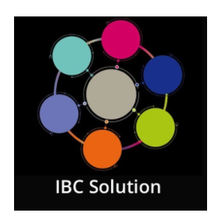

**STEP 1** – Log into the IBC system by clicking once on the **IBC Solution** tile on the KC Net homepage

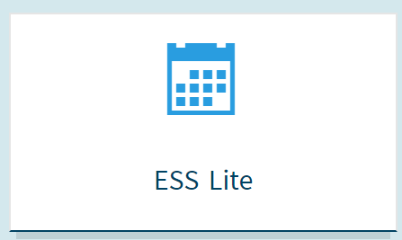

**STEP 2** – Click once on the **ESS Lite** tile that appears on the IBC main page. Doing this will then take you to the employee self-service of the IBC system.

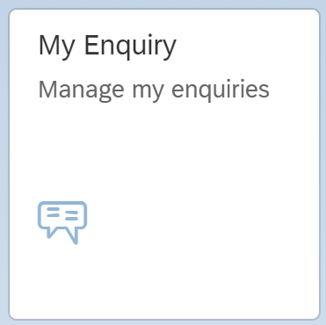

**STEP 3** – Click once on the **My Enquiry** tile, and then when you are in the enquiry screen click once on the **New Query** button (bottom left of the screen)



**STEP 4** – Once in the enquiry screen, click once on the **New Query** button (bottom left of the screen)

**STEP 5** – In the **Create Enquiry** screen, do the following:

* Contact phone number – **enter your phone number**
* Type – select **My Employment / Salary**
* Sub-Type – select **Pensions (RBKC LGPS)**
* Enquiry – select **Valuing Your Benefits – Estimate or CETV request**
* Title – enter **“Pension Estimate”**
* Message – This will depend on the type of estimate you are seeking and therefore you must be clear about the reason. If in doubt, speak to RBKC Pensions first to check. Enter **“Please provide an estimate of my pension benefits based on a proposed date of ….. *(ENTER YOUR CHOSEN LEAVING DATE)* for the purposes of …. *(ENTER THE PROPOSED REASON FOR LEAVING, WHICH WILL BE EITHER (a) VOLUNTARY RESIGNATION BEFORE NORMAL PENSION AGE, or (b) RETIREMENT AT NORMAL PENSION AGE, or (c) RETIREMENT PRIOR TO NORMAL PENSION AGE, or (d) FLEXIBLE RETIREMENT)*.**
* Click the **Send** button on the bottom right. Once you have done this, Hampshire IBC will act on your request by sending to RBKC Pensions an estimate of your projected pensionable pay to your proposed leaving date. RBKC Pensions will then produce the pension estimate.

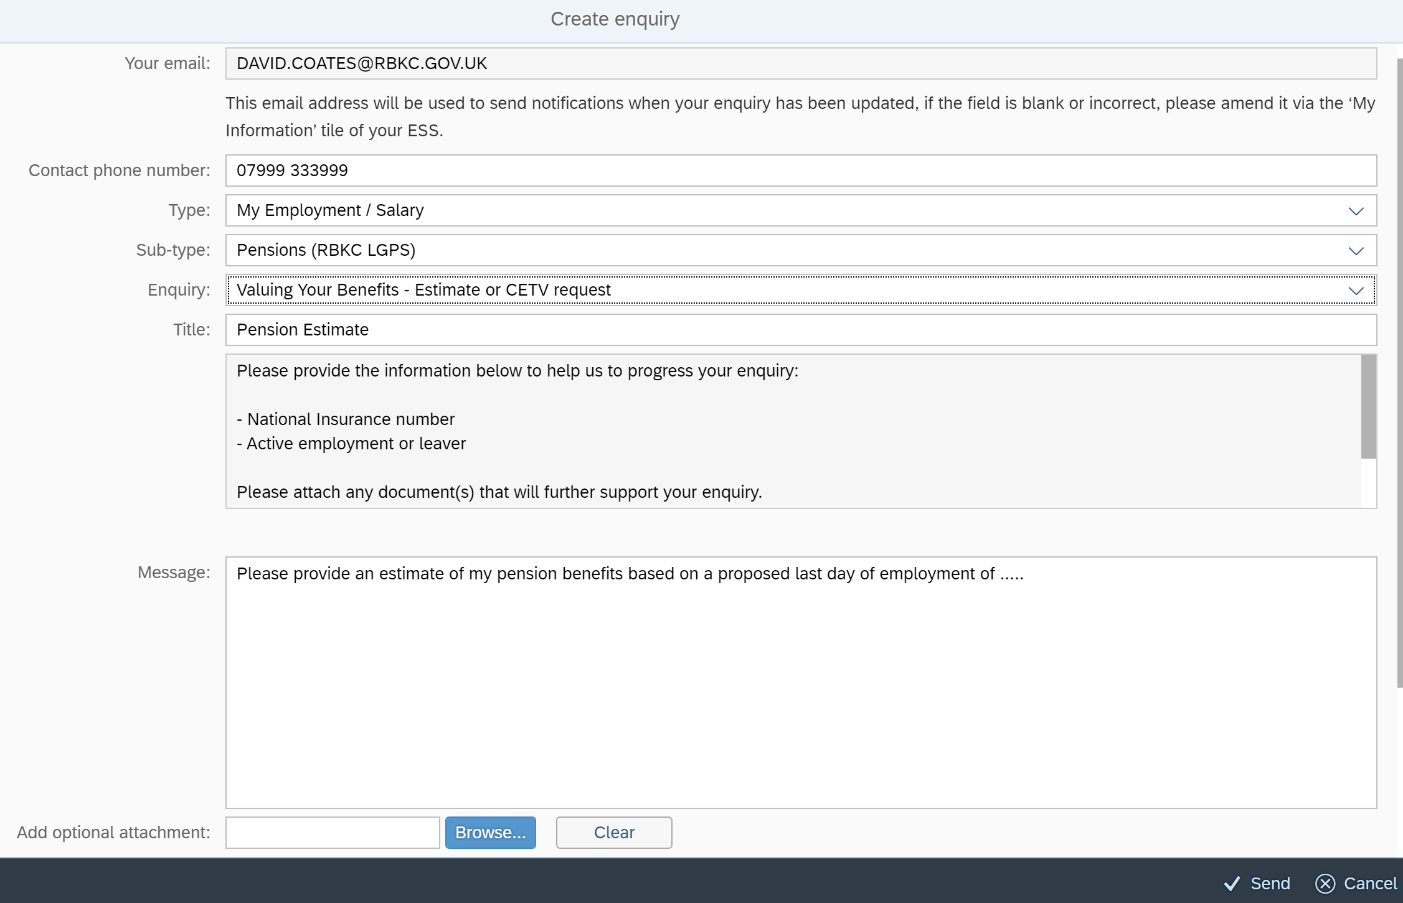

RBKC Pensions

April 2022