**How to move to the 5050 Section of the LGPS using**

**Hampshire’s IBC system**

**(April 2022)**

If you are a user of the Hampshire IBC system, this document explains the process you need to follow to move to the 5050 Section of the LGPS scheme.

**STEP 1** – Complete the 5050 Option Form available from the RBKC LGPS website, using the following link: <https://www.rbkcpensionfund.org/resources/>

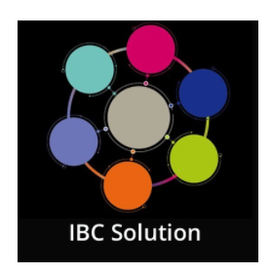

**STEP 2** – Log into the IBC system by clicking once on the **IBC Solution** tile on the KC Net homepage

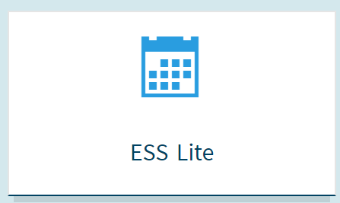

**STEP 3** – Click once on the **ESS Lite** tile that appears on the IBC main page. Doing this will then take you to the employee self-service of the IBC system.

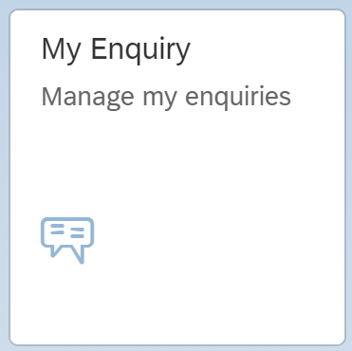

**STEP 4** – Click once on the **My Enquiry** tile, and then when you are in the enquiry screen click once on the **New Query** button (bottom left of the screen)



**STEP 5** – Once in the enquiry screen, click once on the **New Query** button (bottom left of the screen)

**STEP 6** – In the **Create Enquiry** screen, do the following:

* Contact phone number – **enter your phone number**
* Type – select **My Employment / Salary**
* Sub-Type – select **Pensions (RBKC LGPS)**
* Enquiry – select **Reducing or Stopping Pension Contributions – Opt Out or 5050 Request**
* Title – enter **“5050 Section of the LGPS”**
* Message – Enter **“Please enter me into the 5050 Section of the LGPS from the beginning of the next available pay period”**
* Attach your 5050 Option Form using the **Add Optional Attachment** button (bottom left)
* Click the **Send** button on the bottom right. Once you have done this, Hampshire IBC will act on your request.

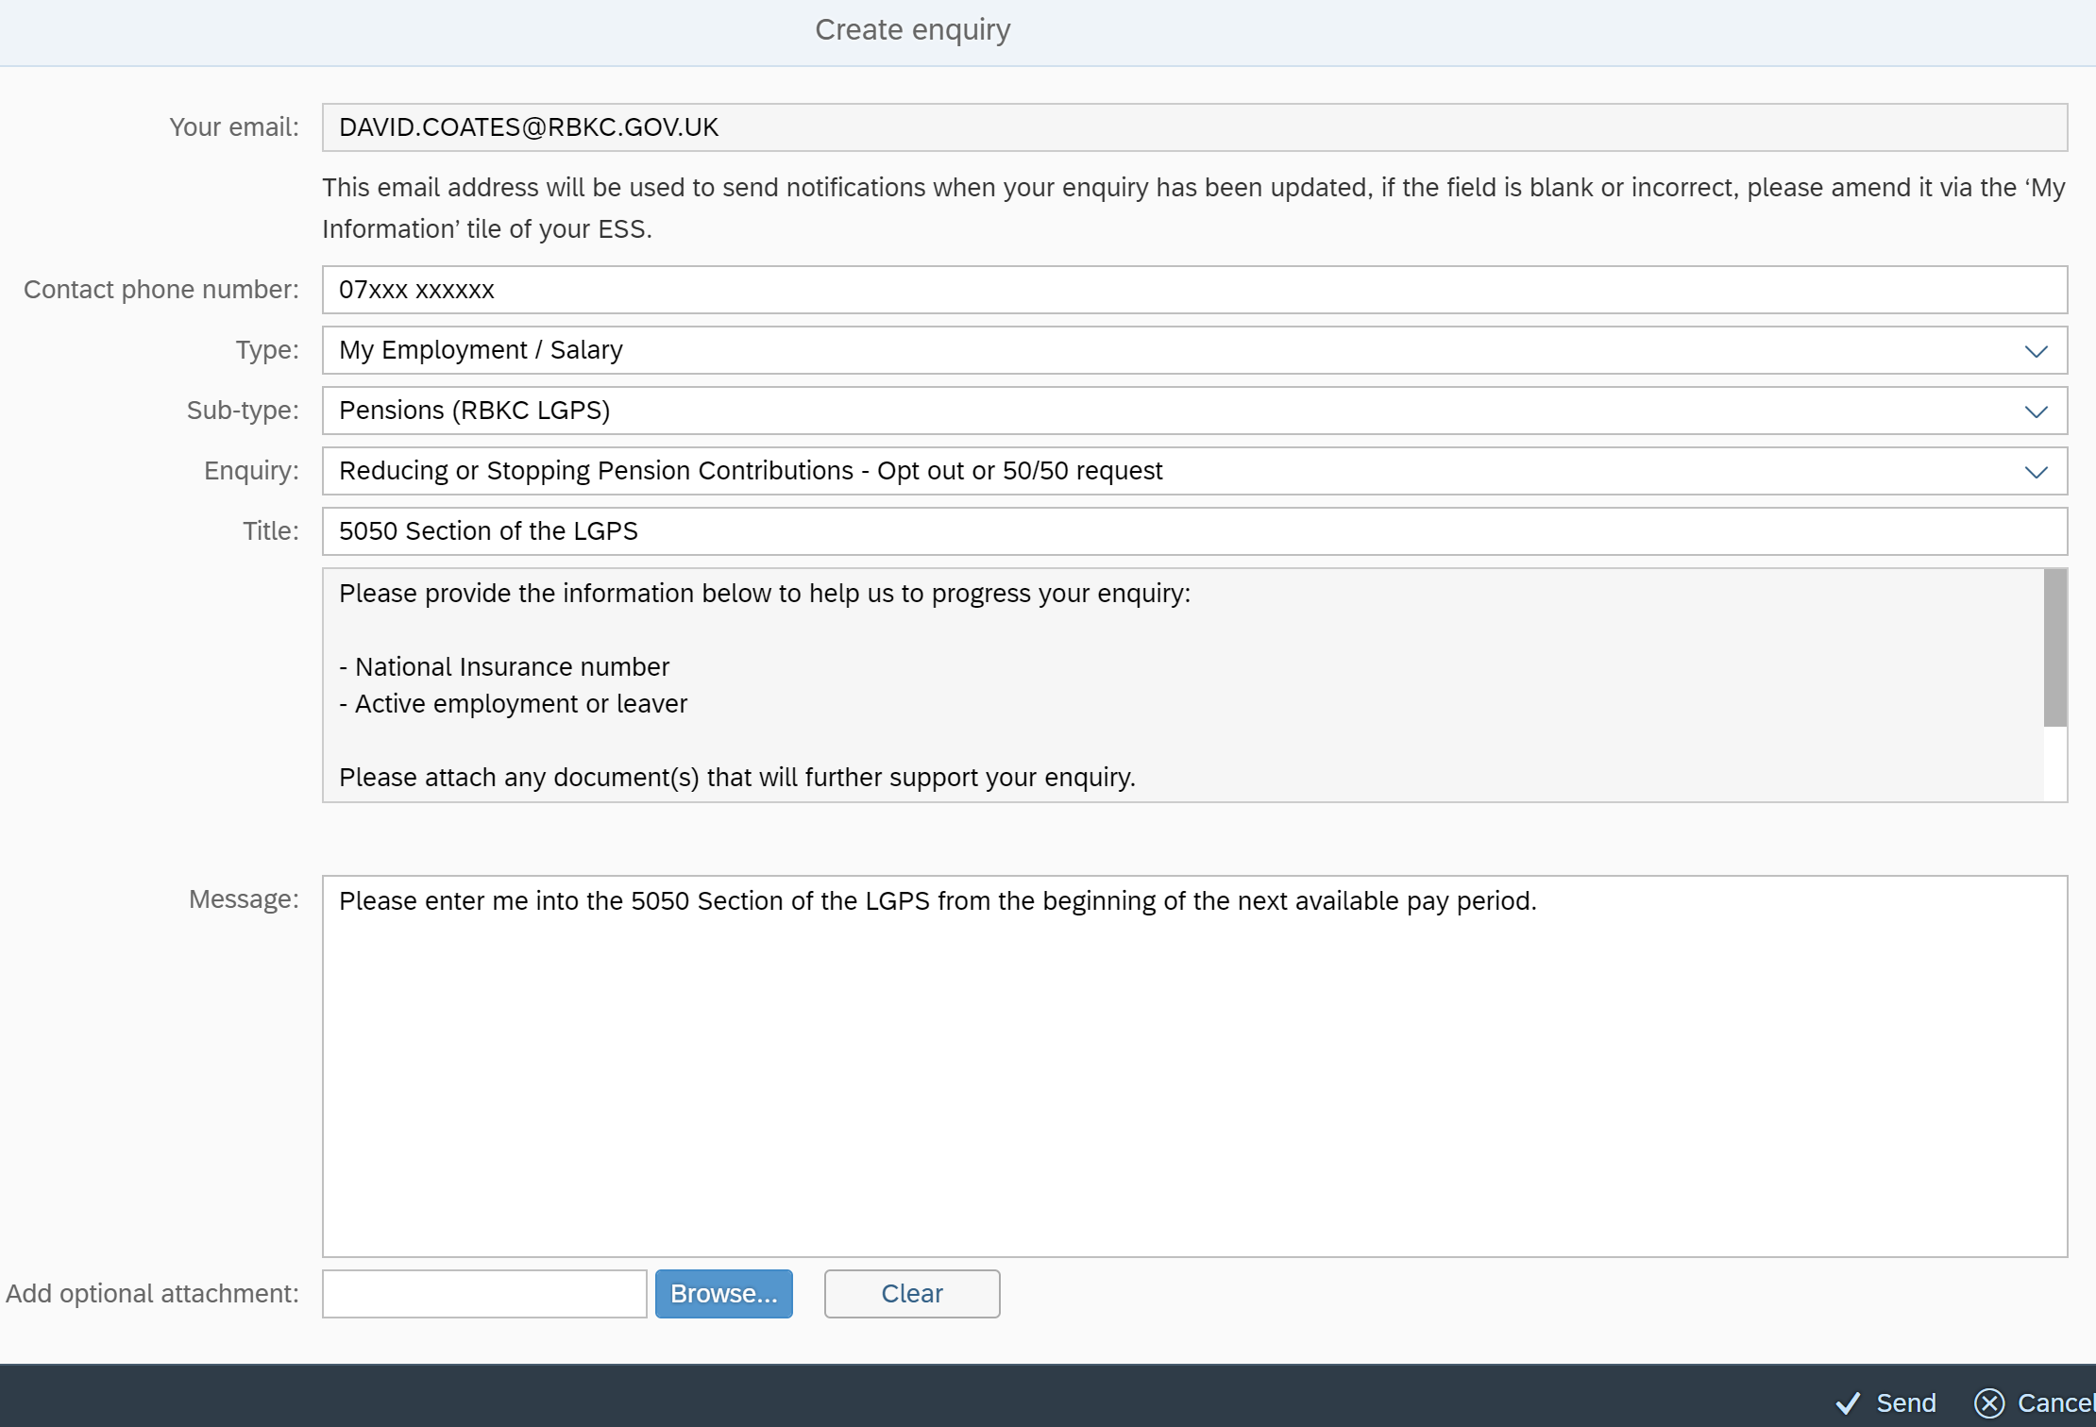

RBKC Pensions

April 2022