**How to voluntarily opt into the LGPS using**

**Hampshire’s IBC system**

**April 2022**

If you are a user of the Hampshire IBC system, this document explains the process you need to follow to voluntarily opt into the LGPS (for example, when you have previously opted out but now wish to opt back in).

**STEP 1** – Complete the LG6 Opt In Form available from the RBKC LGPS website, using the following link: <https://www.rbkcpensionfund.org/resources/>

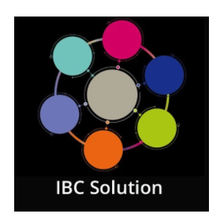

**STEP 2** – Log into the IBC system by clicking once on the **IBC Solution** tile on the KC Net homepage

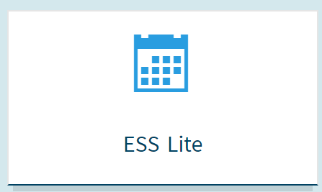

**STEP 3** – Click once on the **ESS Lite** tile that appears on the IBC main page. Doing this will then take you to the employee self-service of the IBC system.

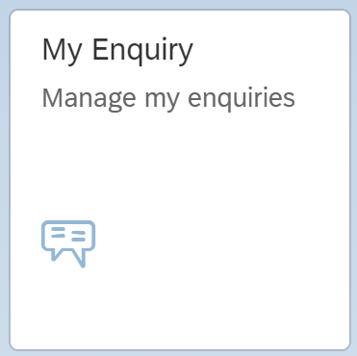

**STEP 4** – Click once on the **My Enquiry** tile, and then when you are in the enquiry screen click once on the **New Query** button (bottom left of the screen)



**STEP 5** – Once in the enquiry screen, click once on the **New Query** button (bottom left of the screen)

**STEP 6** – In the **Create Enquiry** screen, do the following:

* Contact phone number – **enter your phone number**
* Type – select **My Employment / Salary**
* Sub-Type – select **Pensions (RBKC LGPS)**
* Enquiry – select **Joining the Scheme**
* Title – enter **“Opt Into the LGPS”**
* Message – Enter **“Please voluntarily opt me into the LGPS from the beginning of the next available pay period”**
* Attach your LG6 Opt In Form using the **Add Optional Attachment** button (bottom left)
* Click the **Send** button on the bottom right. Once you have done this, Hampshire IBC will act on your request.

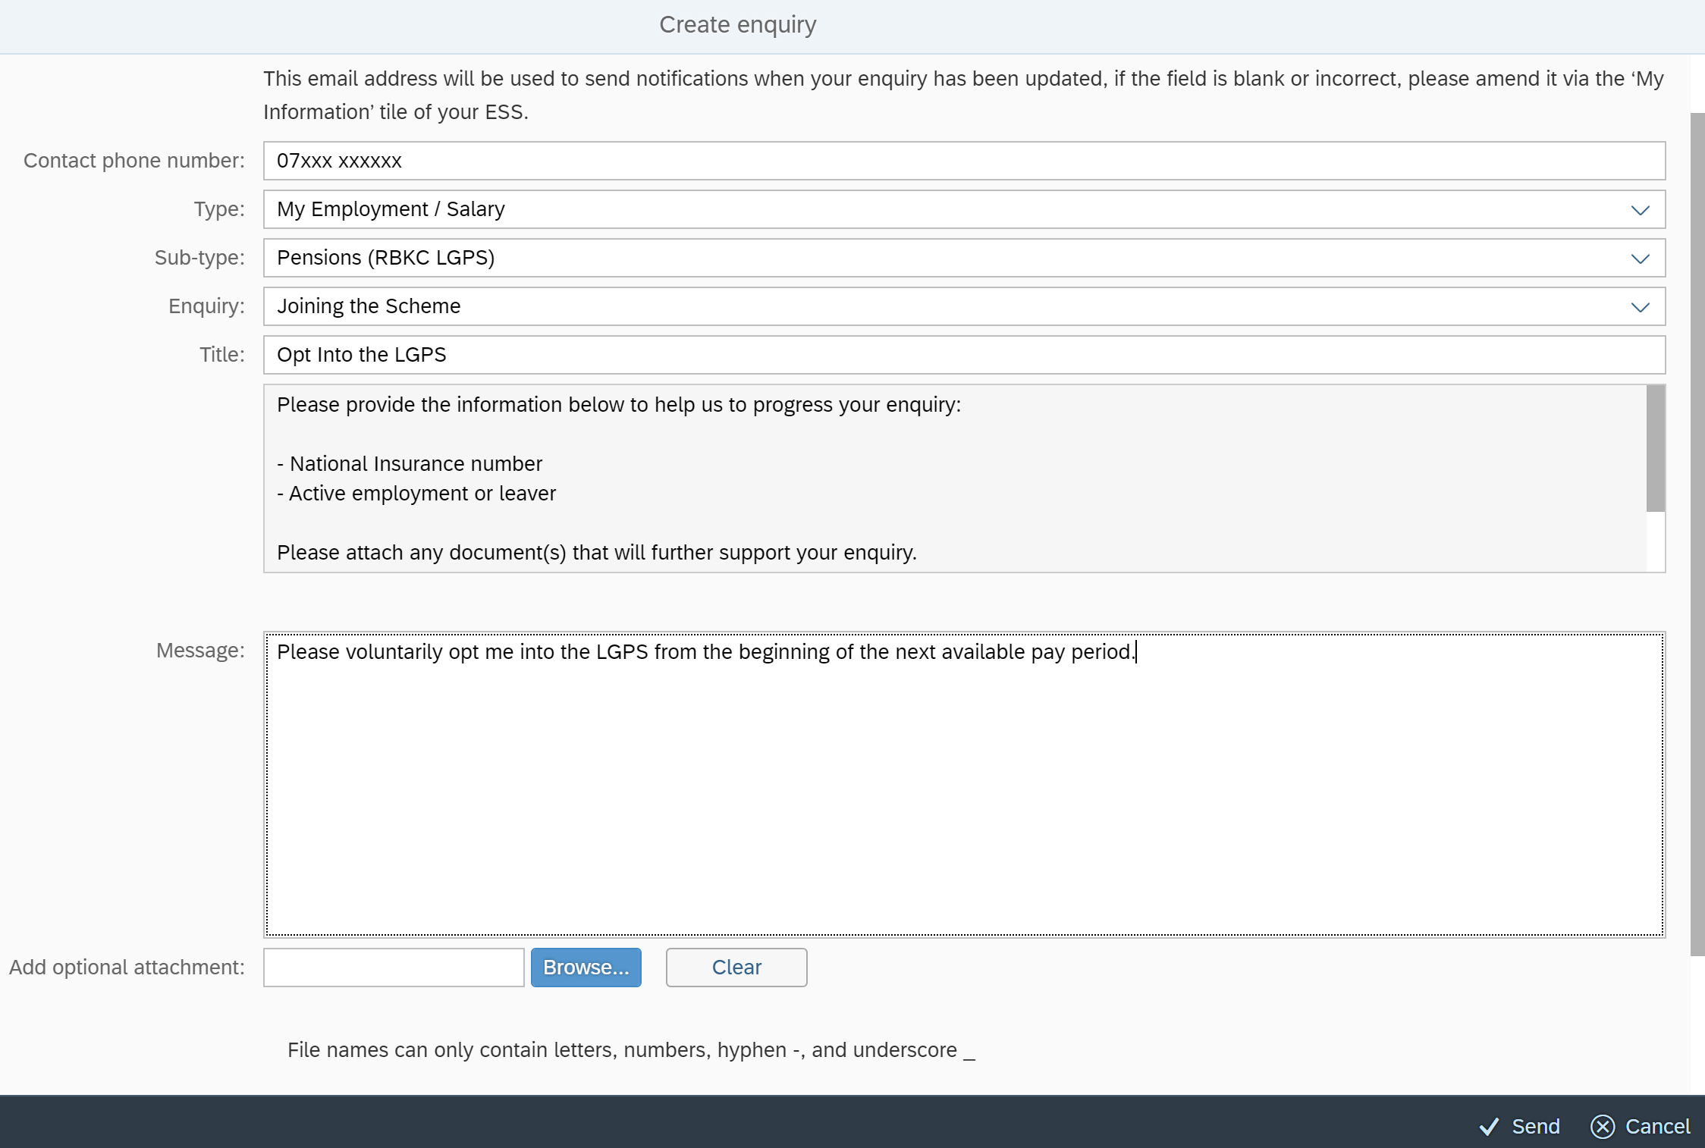

RBKC Pensions

April 2022