**Logging into the RBKC LGPS self-service portal with your Activation Key**

Email: [pensions@rbkc.gov.uk](mailto:pensions@rbkc.gov.uk)

Phone: 020 7361 2323 (9am – 5pm working days)

Website: <https://www.rbkcpensionfund.org>

Dear scheme member, this guidance note explains how to complete the registration process for the RBKC LGPS self-service portal once you receive your activation key.

**STEP 1** - Go to: [**https://mypension.rbkc.gov.uk**](https://mypension.rbkc.gov.uk)

**STEP 2** – On the top right of the screen, click on the **Login** icon

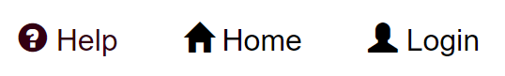

**STEP 3** – click once on the **Complete your registration** link

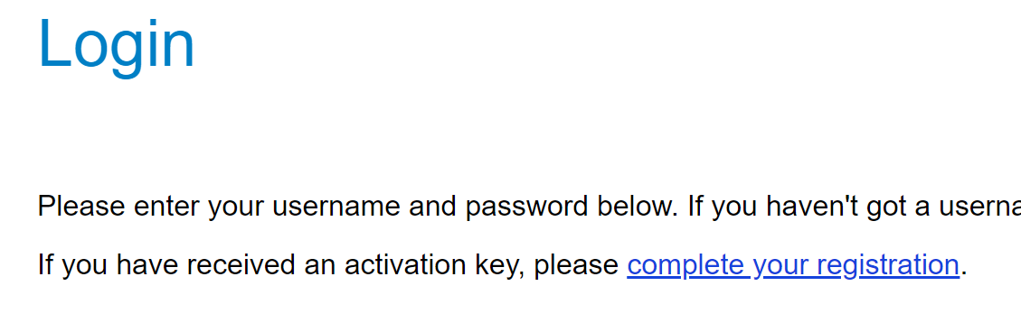

**STEP 4** – The **Activate your Account** screen appears.

Enter your Surname, NI (National Insurance) Number, Date of Birth and Activation Key in each box, then click the **Continue** button once.

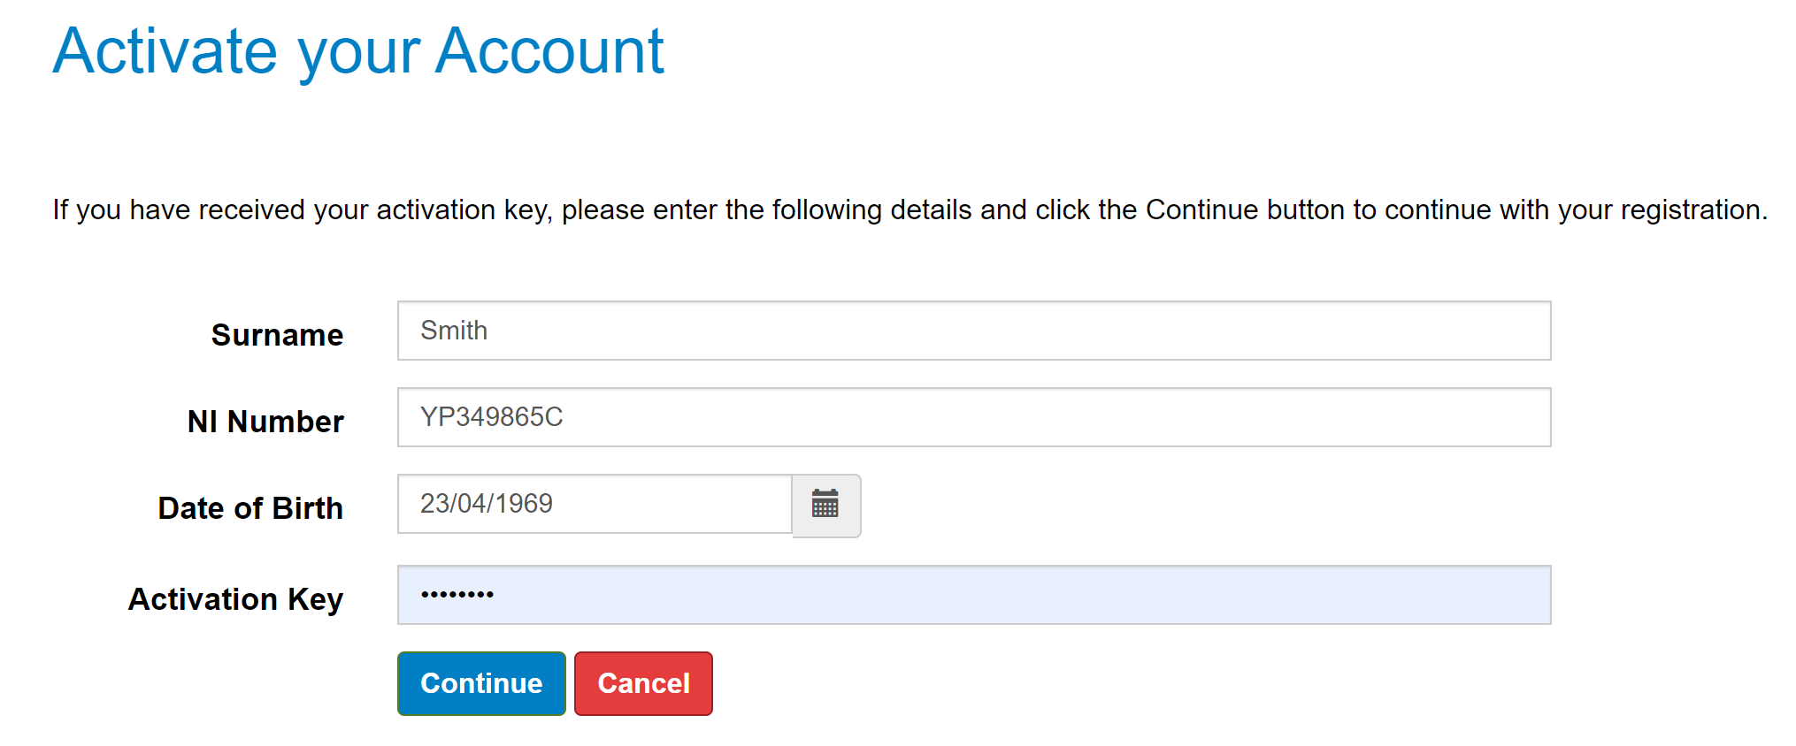

**If all your details are correct and the Activation Key is still valid…**

You will see the Registration Screen, as below. On completion, you will be asked to confirm agreement to the portal’s terms of use, then you can access your pension details. If you do not agree to the terms of use you will be unable to use the portal.

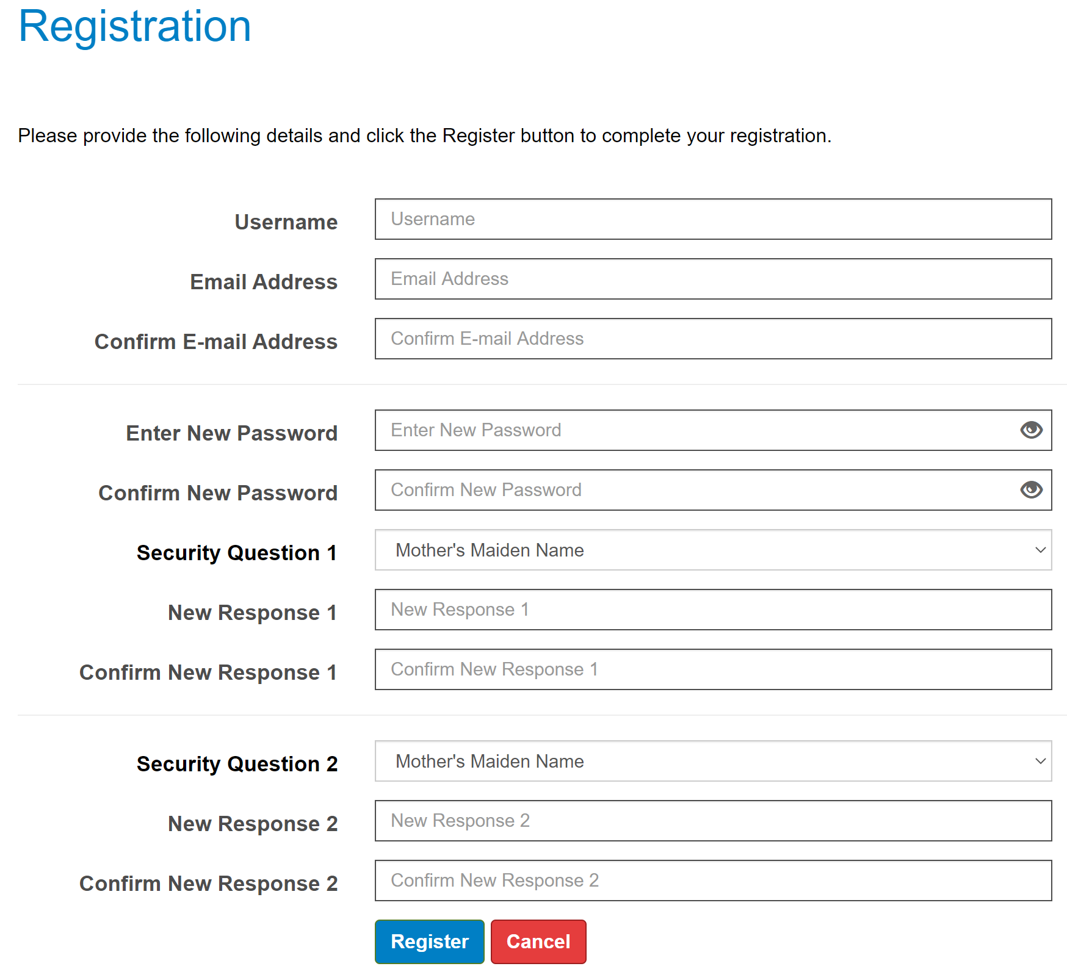

**If your details are correct but the Activation Key has expired…**

The Activation Key is valid for 60 calendar days once issued. If your Activation Key has expired, a message will appear stating this. The Activation Key may also expire if you have attempted to re-register and another Activation Key has since been issued. If either event, you can repeat the registration process and a new Activation Key will be issued. Please remember to check your junk folder in case our email containing your Activation Key has been sent there.

**If you encounter any other issues when registering…**

Please email us at [**pensions@rbkc.gov.uk**](mailto:pensions@rbkc.gov.uk) or phone us on **020 7361 2323**. If emailing, please provide a screen shot of any error message you have received. Thank you.

RBKC Pensions, April 2022